**Sample output**

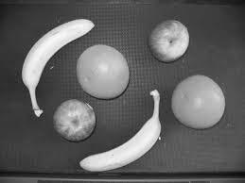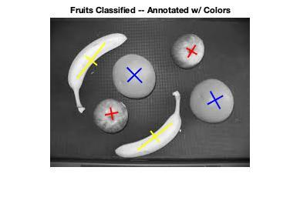

fruits annotated:

Yellow: Banana

Blue: Orange

Red: Apple

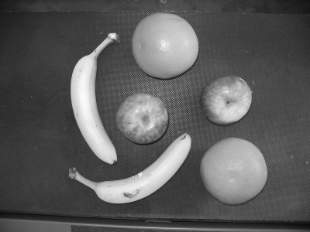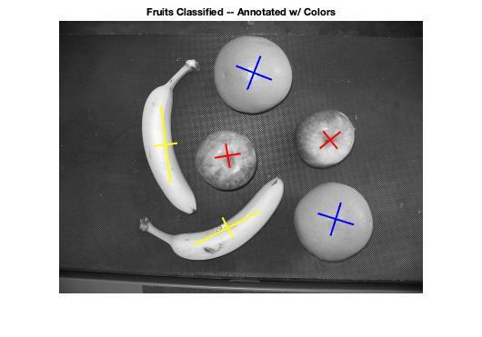

fruits annotated:

Yellow: Banana

Blue: Orange

Red: Apple